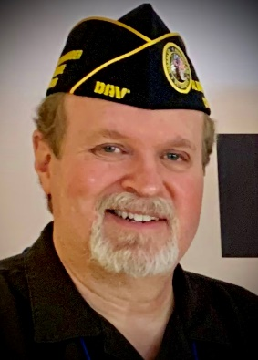

Richard Lehmann
1st. Junior Vice Commander

Richard Lehmann, a service-connected disabled veteran of the U.S. Army became the Department 1st. Junior Vice Commander at the Department of Virginia Convention on 18 June 2022.
The Minnesota native enlisted in the U.S. Army in 1984 and served for five years as a 95B Military Police Officer. He was stationed at Ft. Meade, MD (deployed to Palmerola Air Base, Honduras), Camp Bonifas, Republic of South Korea, and Seneca Army Depot, NY.

Since leaving the military, he earned a Bachelor of Science in Criminal Justice from the SUNY College at Buffalo in 1994 and Juris Doctorate from American University in 1999. He’s worked for CarMax since 2009, moving to the corporate headquarters in Richmond in 2015 to work with the Financial Services & Products, Sales Operations and Asset Protection teams.

A DAV Life Member since 1990, he transferred to Chapter 50 in Chesterfield, VA from Culver City, CA in 2017. Lehmann has held various positions at Chapter 50, including Senior Vice Commander, 2nd Jr Vice Commander and Judge Advocate prior to his election to the Department line.

