Spring Conference 2025

Committee Reports

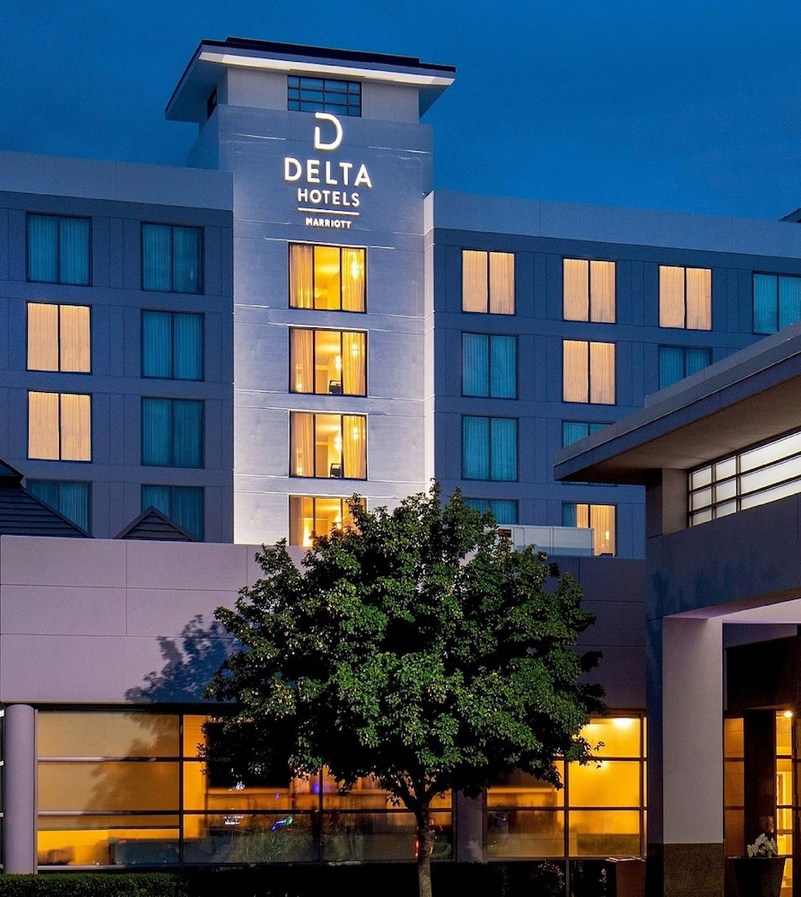

Disabled American Veterans (DAV)

Department of Virginia

P.O. Box 7176

Roanoke, Va 24019-0147

Phone No. (540) 206-2575

Fax No. (540) 206-2925

E-Mail: davadjutantva@gmail.com

Department Website: [www.virginiadav.org](http://www.virginiadav.org)

October 15, 2024

MEMORANDUM

FOR: 2025 Spring Conference

FROM: Rita Aberegg, Audit Chairman

Subject: Report of the Department Audit

This report is for the period 01 July 2023 through 30 June 2024

The Audit Committee met on 15 November 2024 at Department Headquarter to prepare the Annual Financial Report (AFR). The follow committee members were present: Rita Aberegg (7), Chairman; Stephen Perkins (29) Liaison to the Finance Committee, Chris Cheney (60), and Sharon Dorsey Monroe (2).

The committee was provided the AFR with Supporting Documentation and the Financial Statements. Rich Garbe then walked the committee trough the line items and we ensured the numbers were correct. We reviewed the bank statements provided for the General Fund from Atlantic Union Bank; for the Department Service Commission from Atlantic Union Bank, for the Thrift Stores from BB&T Bank and Farmers Market, and for the Money Market from Morgan Stanley and Atlantic Union Bank. I verified the Accounts from QuickBooks were supported. All accounts were traced to the Budget Line Numbers, Chart of Accounts and the AFR.

All check numbers were documented and annotated.

The committee reviewed all 547 vouchers for the year; these vouchers were checked for errors and any discrepancies were provided to the Treasurer. He examined the comments and made the necessary corrections to the satisfaction of the Audit Committee.

I would like to thank the Audit Committee for their diligence and attention to detail in completing the Department of Virginia Annual Financial Report and look forward to the new fiscal year.

Respectfully submitted,

Rita Aberegg

Disabled American Veterans (DAV)

Department of Virginia

P.O. Box 7176

Roanoke, Va 24019-0147

Phone No. (540) 206-2575

Fax No. (540) 206-2925

E-Mail: davadjutantva@gmail.com

Department Website: [www.virginiadav.org](http://www.virginiadav.org)

March 5, 2025

MEMORANDUM

FOR: Department Spring Conference

FROM: Rita Aberegg, Audit Chair

Subject: Report of the Audit Committee

This report is for the period October 19, 2024 through March 6 2025.

The Audit Committee did not meet at the Fall Conference to review the vouchers for 2024 year. The members present were Rita Aberegg (07), Chris Chaney (60) and Sharon Dorsey Monroe (2). Stephen Perkins, a member of the Finance Committee, has reviewed the vouchers at Department Headquarters since the Fall Conference and all discrepancies have been corrected.

The Line Officers have the responsibility to review the Thrift Store Disbursements on a quarterly basis and will provide any input to the chapters at the Spring Conference. The Department Adjutant reviewed some of the Chapters AFR’s and noticed there are some common threads of which lines the expenses are going to that may not be accurate.

Respectfully submitted,

Rita Aberegg

Disabled American Veterans (DAV)

Department of Virginia

P.O. Box 7176

Roanoke, Va 24019-0147

Phone No. (540) 206-2575

Fax No. (540) 206-2925

E-Mail: davadjutantva@gmail.com

Department Website: [www.virginiadav.org](http://www.virginiadav.org)

March 6, 2025

MEMORANDUM

FOR: Department Spring Conference

FROM: Wendell Patrick, Awards Committee Chairperson

Subject: Report on the Awards Committee

This report is for the period October 19, 2024 through March 6 2025.

The Awards Committee for the Department Spring Conference consists of the following members: Wendell Patrick (Chapter 20) Awards Chairperson, Edward Ortiz (Chapter 15), Mark Durland (Chapter 30), Michelle Bickley (Chapter 33), and Charles Morris (Chapter 34). The committee continued with communication through email and Zoom meetings. The concerns of the committee were about the number of Chapters submitting their awards and meeting the deadlines. The committee will continue to work with the Department Commander and Officers to communicate the dates and times of awards submissions. The next awards are for the Department Convention and are due by May 1, 2025. The deadline for the submission date will be determined by the committee.

The following awards are to be submitted for the Department Convention as outlined in the 2023 Department of Virginia Awards directive:

**Outstanding Disabled Veteran of the Year (Al Bartraw, Jr. Award**

**Lifetime Achievement Award (Charlie Craft Ward)**

**Excellence in Leadership Award (John Wesley King II Award)**

**Homeless Veteran Award (Reggie Ruffin Award)**

**Outstanding Local Veterans Representative Award**

**Outstanding Disabled Veteran’s Outreach Program Award**

**Outstanding Employer of the Year**

**Outstanding VAVS Volunteer of the Year**

The committee looks forward to presenting at the Spring Conference. Committee members will be available to answer questions.

Respectfully,

Wendell Patrick, Awards Committee Chairperson

Disabled American Veterans (DAV)

Department of Virginia

P.O. Box 7176

Roanoke, Va 24019-0147

Phone No. (540) 206-2575

Fax No. (540) 206-2925

E-Mail: davadjutantva@gmail.com

Department Website: [www.virginiadav.org](http://www.virginiadav.org)

March 6, 2025

MEMORANDUM

FOR: Department Spring Conference

FROM: PDC Steve Perkins, Chair Pro Temp

Subject: Report of the Finance Committee

This report is for the period October 19, 2024, through March 6, 2025.

The Finance Committee will be meeting, at this conference, to discuss a date for the preparation of a draft budget for the 2025-2026 accounting year. All budget lines will be evaluated, and adjustments made as appropriate. The committee will meet prior to the convention to finalize the draft budget and budget guidelines for presentation at the 4th DEC.

Treasurer Cox advised the committee, per the budget guidelines, the finance committee will meet with the Investment Manager for the annual review of the portfolio at the State Convention. Currently, the stock market is very volatile which requires patience since our funds are in long-term investments.

The Investment Manager will provide updated reports of the department portfolio at this conference.

I hope the conference will be productive, a good learning experience and enjoyable for all my comrades.

Respectfully submitted,

PDC Steve Perkins

Chair Pro Temp

Finance Committee

Disabled American Veterans (DAV)

Department of Virginia

P.O. Box 7176

Roanoke, Va 24019-0147

Phone No. (540) 206-2575

Fax No. (540) 206-2925

E-Mail: davadjutantva@gmail.com

Department Website: [www.virginiadav.org](http://www.virginiadav.org)

March 6, 2025

MEMORANDUM

FOR: Spring Department Conference

FROM: Shamala B. Capizzi, BPTL committee chair

Subject: Report of the Department BPTL committee

This report is for the period from October 19, 2024, through March 6, 2025.

Greetings,

During the reporting period, BPTL has successfully created and distributed newsletters to the department for dissemination among our membership in preparation for mid-winter. Additionally, we coordinated a bus contract with department leadership to ensure that participating members had transportation during DAV Commander’s testimony on Capitol Hill. This initiative included providing status updates to Commander Lehmann and 1st Junior Vice Commander Barkley regarding bus coordination and itinerary for the day of testimony. On Monday, February 24, we also provided prepared snacks to the 1st Junior Vice Commander for distribution to members on the bus.

Lastly, I am pleased to announce that the Department of Virginia was recognized with the Outstanding Advocacy Award for the second consecutive year.

Respectfully submitted

Shamala B. Capizzi

Disabled American Veterans (DAV)

Department of Virginia

P.O. Box 7176

Roanoke, Va 24019-0147

Phone No. (540) 206-2575

Fax No. (540) 206-2925

E-Mail: davadjutantva@gmail.com

Department Website: [www.virginiadav.org](http://www.virginiadav.org)

March 6, 2025

MEMORANDUM

FOR: Department Spring Conference

FROM: Dr. MaLinda B. Washington, Membership Committee Chair

Subject: Report of the Committee

This report is for the period October 19, 2024 through March 6 2025.

The Membership Committee is comprised of five appointed members. Department 2nd Jr. Vice Commander Marcia Stewart serves as the Committee Ex-Officio and MaLinda Washington was elected by the appointed Membership Committee as Chair. The members appointed for the year 2024-2025 are as follows:

M. Tyrelle Felder Chapter 33

Edward Ortiz Chapter 15

Rhonda Rawson Chapter 30

James Stevens Chapter 27

MaLinda Washington Chapter 17

The Membership Committee continues to work within the Bylaws: **“Para 11.1 Shall establish a Department Membership Program to be carried out in addition to any ongoing Chapter or National membership program and provide during each Conference and Convention a report indicating the results of the Department Membership Recruitment Program.” “Para 11.2 Shall be responsible for assisting in the formation of new Chapters in the Department of Virginia, utilizing guidelines set forth in the National Bylaws, and shall make recommendations to the DEC for approval of new Chapters.**

The Committee Chair continues to meet with the Department 2nd Jr. Vice Commander Marcia Stewart to discuss and ensure the established Membership goals for 2024 – 2025 are achieved.

**Established Department Membership Goals for 2024-2025:**

* 100% Attainment of Department Membership Goal
* 10% of Part-Life converted to Full-Life
* 100% Goal attainment for Department
* VA Win for March Madness/March Madness Event
* Statewide Membership Same Day Drive
* CSO Statewide/Hampton Roads Day
* Day before Conference/Convention

The Membership Committee has met three of the six Department Membership goals. The three goals met are:

* Statewide Membership Same Day Drive
* CSO Statewide/Hampton Roads Day
* Day before Conference/Convention

The Membership Committee meeting is held once a month for one hour using the zoom platform. The Committee met to discuss strategies to accomplish the established goals and ensure chapters have any resources needed to help with their success.

The Membership Committee worked with the Chapters to develop and implement strategic plans to have a successful year. The Committee is working hard to ensure there is excellent communication and teamwork with achieving the 2024-2025 goals. Committee members provided support and discussed Chapter events to help them meet their goals.

**Committee Membership Meetings:**

* November 25, 2024
* January 25, 2025
* March 3, 2025

The Membership Committee hosted and/or attended the following events to help achieve goal attainment.

**List of Past Events:**

* February 1, 2025 – Attended an event that was held in Leesburg, VA to discuss the opportunity to open a new Chapter in Loudoun County. The following individuals attended the event to help with the support: Rich Lehmann, Department Commander, Kim Barkley, 1st Junior Vice Commander, and Marcia Stewart, 2nd Junior Vice Commander. In addition, the Membership Committee members that attended were The Membership Committee Chair MaLinda Washington and Ed Ortiz, Chapter 15. Commander Lehmann lead the presentation with support from Ed Ortiz.
* November 9, 2024 – Membership Gala held at Chapter 17. The Vietnam Veterans were recognized and other veterans as well. Certificates and pins were given to the veterans. Also, the Fallen Soldiers, MIA and POW were recognized and a table was set up in their honor. This was a successful event and there were several guests who joined DAV and/or made a donation to the Chapter.
* November 14, 2024 - Hampton Roads Wine Expo Sponsorship Mixer. The event was an opportunity to introduce DAV to the Sponsors of the Hampton Roads Wine Expo. The event was a test site to determine if the Membership Committee could use it to gain members and set up a booth at the event. We were able to get individuals to sign-up for a follow up meeting at Golden Corral in Newport News.
* November 21, 2024 – Newport News Golden Corral Membership and Claim Support. This was a follow-up meeting from the November 14, 2024 event. MaLinda Washington, Shay Odom and Maurice Hammond provided CSO Claim Support and membership sign-up using Recruit a Warrior. It was a very successful event.
* December 6, 2024 – Funeral Director’s event in Emporia. This meeting allowed the Committee Chair to discuss opportunities to work together. We will provide claim support for families that may need support. It was a wonderful experience and we have gained members from this opportunity. MaLinda Washington and Diana Lambert attended the event. Lincoln Ball, William Reed, Diana Lambert and MaLinda Washington assisted with Membership and claim support follow-up.

Several virtual meetings and conference calls were conducted by the Committee Chair to DAV Chapters to provide support and resources to ensure their events are successful. Also, meetings were held with organizations and community members to grow DAV Membership and help meet the DAV goals and grow the brand of DAV.

The Committee Chair reviewed the March 5, 2025 report and the Department needed 503 members to meet the total goal for the year. The following Chapters have met goal as of March 3, 2025 (13, 15, 22, 27, 34, 50, 58).

The Committee is continuing to work to ensure March Madness is a success and the goal for 2024-2025 are met.

Respectfully submitted,

Dr. MaLinda Washington

Membership Committee Chair

Disabled American Veterans(DAV)

Department of Virginia

P.O. Box 7176

Roanoke, Va 24019-0147

Phone No. (540) 206-2575

Fax No. (540) 206-2925

E-Mail: [davadjutantva@gmail.com](mailto:virginiadavhq@cox.net)

Department Website: [www.virginiadav.org](http://www.virginiadav.org)

March 6th, 2025

FOR: Department Spring Conference

FROM: Raul M. Muntean Chair, DAV Department of Virginia Emergency Relief Committee

Michele Hinton Chair, DAV Department of Virginia Homeless Committee

Subject: Report of the Emergency Relief and Homeless Committee

This report is for the period October 19th, 2024, thru March 6th, 2025

Warmest Greetings, Department CMDR Richard Lehmann, Respectable DSD Cynthia Bailey, Respectable Department Adjutant Lisa Gregory, Respectable Department of Virginia Executive Officers, and Fellow Comrades.

Acknowledgments:

To date, 2025 has been filled with the privilege of servitude in the lives of our fellow veterans in need who have been seeking financial assistance from the DAV. This opportunity to serve our veterans has not presented itself without many increased challenges due to the increase of the financial strain based on our social and economic climate, inflation, and the wages gap to the cost of living expenses.

As the DAV Department of Virginia ER and Homeless Chair members, we are grateful to have a World-Class Team that has provided tremendous support in our efforts to steward the DAV organization's funds and provide financial assistance to our veterans in need.

Special Acknowledgments:

Department Service Director PDC Cynthia Bailey, Michele Hinton, Homeless Chair,

PDC Denice Williams, Comrades Kim Tomas, Regina Lawrence, Keith Shaner, Zeola Brady,

John Simmons, and Thomas Cahoon.

The above-mentioned DAV Comrades are amongst the many that deserve our Highest Gratitude when it comes to providing help with veterans homelessness and emergency relief. This year on Jan. 20th 2025, as the Nation celebrated and honored the life and legacy of Dr. Rev. Martin Luther King Jr., as the nation enjoyed a day of rest, our DAV comrades were hard at work. Due to the tremendous hard work of the honorable comrades mentioned above, on that day alone we were able to assist six veterans and personally deliver and distribute more than $5000 worth of assistance. Along with myself, comrades John Simmons, Thomas Cahoon, Kim Tomas, and Zeola Brady, were in the office and out delivering checks that resulted, amongst others, in the eviction prevention for a cancer survival disabled veteran.

With utmost gratitude we say thank you.

Raul M. Muntean Chair, DAV Department of Virginia Emergency Relief Committee

Michele Hinton Chair, DAV Department of Virginia Homeless Committee

Progress:

With the Support and Guidance of our Department DSD Cynthia Bailey, the Emergency Relief & Homeless Committees have worked hand in hand with numerous chapters and provided the following financial assistance to veterans in need:

Department ER Committee $13,517.536

Department Homeless Committee $9695.70

While at the department level, we assisted 21 veterans with $23,213.23, we have worked hand in hand with various chapters to provide assistance and connect with more than one hundred plus veterans.

During this reporting period, the ER Chair conducted live ER training with its Respectable Committee Members on call with veterans and held additional ER training with several DAV Chapters.

Goals

1.Continue to provide recommendations to the Department and work on Standard Written Guidelines for Emergency Relief and the Homeless program so that we can efficiently, in good stewardship, serve more veterans by strengthening our DAV Virginia Department and our Chapters.

2. In keeping with our DAV Mission Statement and with gratitude for the honorable servitude of our fellow veterans, it is our Goal to personally connect with every veteran who requests assistance from the DAV Department of Virginia, regardless of whether we can assist. We want to thank every veteran for their servitude, point them to additional DAV Services, and refer them to outside resources as needed. In providing assistance, we also want veterans to have the opportunity to join the DAV by connecting them with local chapters.

3. (I see you, and you matter)

With the increase in Veterans’ Suicide, the DAV ER, Homeless Team, and local Chapters have an opportunity to connect with veterans during their time of financial crisis, and we must let veterans know they have value beyond their circumstances and that veterans matter and are not ignored by our society.

Emergency Relief Committee email: [**ER.VirginiaDAV@gmail.com**](mailto:er.virginiadav@gmail.com?subject=email%20via%20the%20dept.%20website)

Homeless Committee email: [**HomelessVet.VirginiaDav@gmail.com**](mailto:HomelessVet.VirginiaDav@gmail.com?subject=email%20via%20the%20dept.%20website)

Respectfully submitted,

Raul M. Muntean Chair,

DAV Department of Virginia Emergency Relief Committee

Michele Hinton Chair,

DAV Department of Virginia Homeless Committee

Disabled American Veterans (DAV)

Department of Virginia

P.O. Box 7176

Roanoke, Va 24019-0147

Phone No. (540) 206-2575

Fax No. (540) 206-2925

E-Mail: davadjutantva@gmail.com

Department Website: [www.virginiadav.org](http://www.virginiadav.org)

March 6, 2025

MEMORANDUM

FOR: Department Spring Conference

FROM: Valerie Gray, Chair

Subject: Report of the Women Veterans Committee (WVC)

This report is for the period October 19, 2024, through March 6, 2025.

Committee Meetings:

**November 18, 2024 – Chapters in attendance: 7, 20, 21, 22, 27, 34, 50**

We spoke about the upcoming Virginia Women’s Conference offered by Senator Mark Warner and asked who would like to attend. The following people advised they would attend: 1st JR Vice Commander Kimberly Barkley Chapter 27 and two members from her chapter, 2nd JR Vice Commander Marcia Stewart Chapter 21, Women’s Chair Valerie Gray Chapter 21, and Herb Jones Chapter 34. Chapter 22 Dr. Danielle Williams advised she email her chapter to see who would be interested in attending.

**March 5, 2025 - Chapters in attendance: 7, 15, 20, 21, 22, 27, 28, 34**

The following topics were discussed at the meeting:

**Upcoming Events**

**Virginia Women Veterans Week March 16-22, 2025**

To commemorate this week, the Virginia Department of Veterans Services will host a special Honoring Women Veterans ceremony and luncheon on March 20, 2025 beginning at 10 a.m. The event will include guest speakers, tributes to women veterans, the presentation of special lapel pins, and other activities to connect and uplift the women veteran community and to inspire new generations of women to serve in the U.S. military.

https://www.dvs.virginia.gov/Home/Components/News/News/148/83

There is no charge to attend the ceremony or lunch, but the number of lunch participants is capped at 100 – RSVP is required. There are two options for attending:

1. Ceremony Only (open to all):to attend only the Ceremony, please RSVP using the Ceremony Only link here.

2. Ceremony & Luncheon (capped at 100 – women veterans only, please):to attend both the Ceremony and the Luncheon, please RSVP using the Ceremony and Luncheon link here (this link will indicate attendance for both events).

Luncheon attendance is limited to the first 100 women veterans who RSVP. The event will take place at the Virginia War Memorial, located at 621 South Belvidere Street, Richmond, VA 23220. For more information, please visit www.dvs.virginia.gov, email womenvet@dvs.virginia.gov or call (804) 786-0571.

**Women Veteran Interactive**

3rd Annual National Women Veterans Pink and White Empowerment Summit

March 28, 2025 Evening Reception

March 29, 2025 Daylong Summit

**Women Veteran Engage** – May 31, 2025 8AM-3PM PDT

https://www.womenveteransalliance.com/women-veterans-engage/

Feb 5, 2025 Congresswoman Julia Brownley (D-CA) announced the reintroduction of a resolution supporting the naming of new or undedicated U.S. Department of Veterans Affairs (VA) facilities after women veterans and minority veterans.

**Pajama Pizza Party** – Spring Conference

**Women’s Retreat** - August or September

The following events were attended by the committee members:

November 23, 2024 – Attended the 12th Annual Virginia Women’s Conference: Elevate Your Future sponsored by Senator Mark Warner (Valerie Gray). There were six people that attended the conference: two each from Chapter 21 and 27, and one each Chapter 20 and 34. We had a table with the Department 2nd Jr Vice Commander and gave out information to veterans. I spoke with several women veterans and even gave them information to join the local chapters in the area.

December 21, 2024 – Attended Chapter 28 Christmas Party – Valerie Gray

Respectfully submitted,

Valerie Gray, Chairperson  
Women Veterans Committee