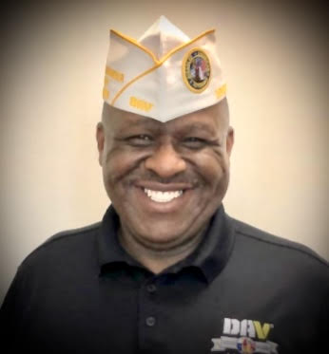

Dwayne Ramey
2nd Junior Vice Commander

Dwayne Ramey, a service-connected disabled veteran of the U.S. Navy became the Department 2nd Junior Vice Commander at the Department of Virginia Convention on 18 June 2022.
The Illinois native enlisted in the U.S. Navy in 1978 and retired after thirty years as a Master Chief Legalman in August 2008. Ramey served on four ships: USS Sierra, USS Texas, USS Coral Sea, and USS La Moure County.
After retirement, Ramey joined the Department of the Navy Personnel Claims Unit from 2008-Present. Ramey has a degree in Vocational Education and Development and is a graduate of the Navy Senior Enlisted Academy.
Residing in Norfolk, VA, he joined DAV Chapter 20 Virginia Beach in 2008. He has held various positions within Chapter 20 to include Commander, Adjutant for 9 years, Finance Chairman, Chapter Executive Committee membership representative and Department Executive Committee member for 6 years.
Prior to his election to the Department Line Ramey served as the Assistant Department Inspector, and on the Homeless Veterans Committee Member and the Legislative Committee.

