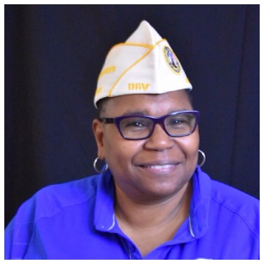

Cynthia R. Bailey
Department Service Director

Cynthia R. Bailey, a service-connected veteran of both the U.S. Army Reserve and U.S. Navy, was appointed as the Department Service Director on 17 June 2023. She previously served as the Department Commander from 2021 – 2022.

Bailey enlisted the U.S. Army Reserve in 1986 and transferred to the U.S. Navy in 1987 where she served until 1997 as a Culinary Specialist.

Since leaving the military, she earned an Associate in Applied Science Degree in Information Systems Technology from Tidewater Community College in Virginia Beach, Virginia in 2001.

A life member of DAV Chapter 20 in Virginia Beach, Virginia since 2014 she became a Chapter Service Officer, chaired the Building & Grounds Committee, and was elected to 3 consecutive terms as Chapter Commander starting in 2016 prior to becoming a Department Line Officer.

