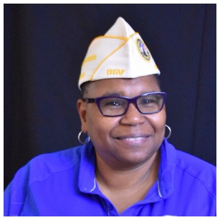

Cynthia R. Bailey
Immediate Past Department Commander

Cynthia R. Bailey, a service-connected veteran of both the U.S. Army Reserve and U.S. Navy, became the Immediate Past Department Commander on 18 June 2022 when she was succeeded by Commander Francis Mitchell.

Bailey enlisted the U.S. Army Reserve in 1986 and transferred to the U.S. Navy in 1987 where she served until 1997 as a Culinary Specialist.

Since leaving the military, she earned an Associate in Applied Science Degree in Information Systems Technology from Tidewater Community College in Virginia Beach, Virginia in 2001.

A life member of DAV Chapter 20 in Virginia Beach, Virginia since 2014 she became a Chapter Service Officer, chaired the Building & Grounds Committee, and was elected to 3 consecutive terms as Chapter Commander starting in 2016 prior to becoming a Department Line Officer.

