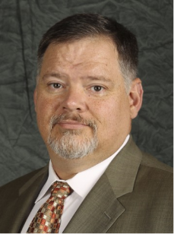

Stephen C. Combs
Judge Advocate

Stephen C. Combs, a service-connected disabled Marine Corps veteran, was re-elected Judge Advocate at the 2022 DAV Department of Virginia Convention, in Roanoke, Virginia on 18 June 2022.

Stephen enlisted in the U. S. Marine Corps in 1986 and was discharged in 1994. He earned an Associate Degree in Criminal Justice in 1995, however due to disabilities incurred in the Marine Corps he was unable to pursue a career in Law Enforcement.

In October 1995 Stephen was hired by DAV as a National Service Officer and worked in the Regional Offices in Winston-Salem (NC), Louisville (KY), and Atlanta (GA) before moving to the Board of Veterans Appeals in 2004. In 2008 he was admitted to the bar for the US Court of Appeals for Veterans Claims as a non-attorney practitioner. During this time, Stephen served in various leadership positions in numerous Chapters and Departments.

Stephen also has volunteered his time as a volunteer Firefighter and Reserve Police Officer, both in NC; and is a of member of numerous other Veterans Service Organizations (VSOs).

After returning to school in 2007, he earned a BS in Industrial and Organizational Psychology, and in 2013 earned a Master’s Degree in Community Counseling.

A life member of DAV General Washington Chapter 7 in Fredericksburg, his experience (AA degree in Criminal Justice and nearly 24 years as an NSO) enables him to quickly identify and correctly react to potential or actual problems that may occur in respect to violations of the DAV Constitution and Bylaws. In 2016 Stephen was unanimously elected as the Department of Virginia Judge Advocate and has been re-elected every year since then.

