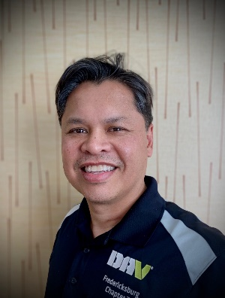

Wilton King
Senior Vice Commander

Wilton King, a service-connected disabled veteran of the U.S. Navy became the Department Senior Vice commander on 18 June 2022.
The Michigan native joined the Navy in 1993 and ended his service after ten years as a Signalman First Class. He was assigned to four ships: USS Sylvania (AFS-2), USS D.D. Eisenhower, USS Carl Vinson, and USS Portland. He was honorably discharged in February 2003.

After discharge, King joined the U.S. Capitol Police from 2003-2007 then changed agencies to the U.S. Air Marshal Service. He retired from Federal Law Enforcement in September 2015.

Wilton has a degree in Liberal Arts with a Concentration in Weapons of Mass Destruction. He has been certified as a National-Emergency Medical Technician, HAZMAT Specialist and a Personal Trainer.

Residing in Fauquier County, VA, he transferred to General Washington Chapter 7 in Fredericksburg, VA from Goshen, NY in 2015. Wilton has held various positions within Chapter 7 to include Commander, Jr. Vice Commander as well as serving as a Van Driver and Chapter Service Officer

Prior to his election to the Department Line, King served as Assistant Department Inspector, and as the Chair of the Homeless Veteran Committee, and served on the Emergency Relief Committee.

