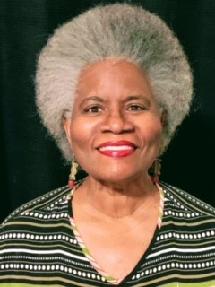

Patricia Coker-Bell
Department Chaplain

Patricia Coker-Bell, a service-connected disabled U.S. Army veteran, was Re-elected as Department Chaplain at the 2022 DAV Department of Virginia Convention in Roanoke, VA on 18 June 2022.

After serving 13 years in the US Army and Army Reserve; Coker-Bell attended Norfolk State University and received both a Bachelor of Science Degree (Magna Cum Laude) and a Master of Arts Degree in Education. She then attended Samuel Dewitt Proctor School of Theology and received a Master of Divinity and Doctor of Ministry degrees. Patricia served twenty years as a teacher in the Chesapeake Public City Schools, has been an instructor on the collegiate level at Virginia University of Lynchburg and Tidewater Community College.

A Life Member of Portsmouth Federal Chapter 22, she has served as the Chapter Adjutant, a Chapter Service Officer and as a member of the Emergency Relief Committee.

Prior to her election as the Department Chaplain in 2021, Patricia served as the Chair of the DAV Department of Virginia Women Veterans Committee, and as an Assistant Chaplain.

